IBM

Smart Home Automation Assignment – 1

Tinker Cad:

<https://www.tinkercad.com/things/j8TqlR2TaL3-super-lahdi-allis/editel?sharecode=GzB22dlHxG5dzx6WNwoDoJVqukyRNnoFcpyNVHVuXhw>

Circuit Diagram:

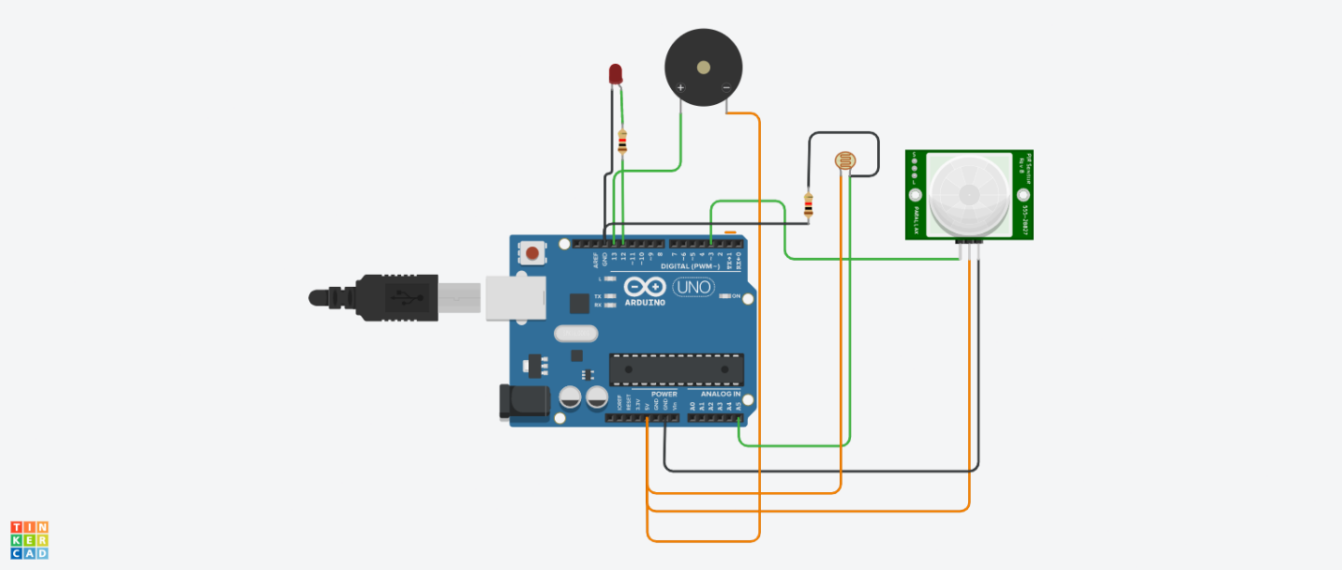

Source Code:

int led = 12;

int buzzer = 13;

int Msensor = 3;

int Lsensor = A5;

int Lval = 0;

int Mval = 0;

int Threshold = 400;

void setup() {

pinMode(led, OUTPUT);

pinMode(buzzer, OUTPUT);

pinMode(Lsensor, INPUT);

pinMode(Msensor, INPUT);

Serial.begin(9600);

}

void loop()

{

delay(1000);

Serial.println("!!!!!!!!!!!!!!!!!!!!!!!!!!!!");

Lval = analogRead(Lsensor);

Serial.println(Lval); //Light Intensity

if (Lval > Threshold)

{

digitalWrite(led, LOW);

Serial.println("Day Time");

}

else

{

digitalWrite(led, HIGH);

Serial.println("Night Time");

}

Mval = digitalRead(Msensor);

if(Mval == HIGH)

{

tone(buzzer,1000);

Serial.println("Motion is Detected");

}

else

{

tone(buzzer,0);

Serial.println("No Motion");

}

}